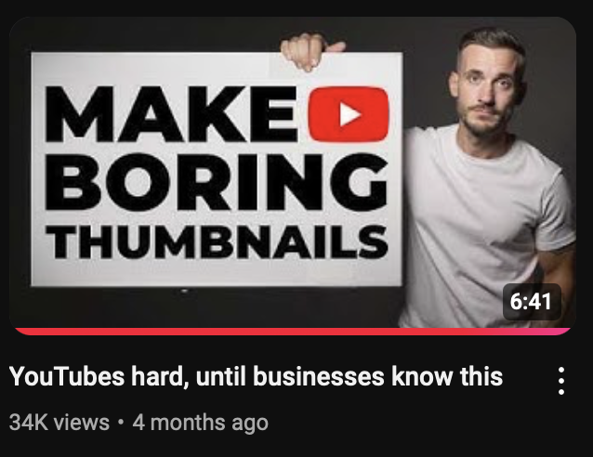

Intro
Transition
Example
Application
END
Can I tell you a secret?
I've worked with hundreds of YouTube creators over the years and discovered there's one type of thumbnail that's really easy and fast to make, performs VERY well, and it's potentially all you need to generate more views and sales for your business.
So today, I'm going to show you:
- Examples of channels blowing up using this simple style
- How to easily create it for yourself
- And how to get YouTube to tell you how effective your image
To start lets look at a channel exploding using this method
And you can see how effective its been from the social blade data on screen right now.
What’s great about their strategy is they keep their images so simple literally anyone could make them

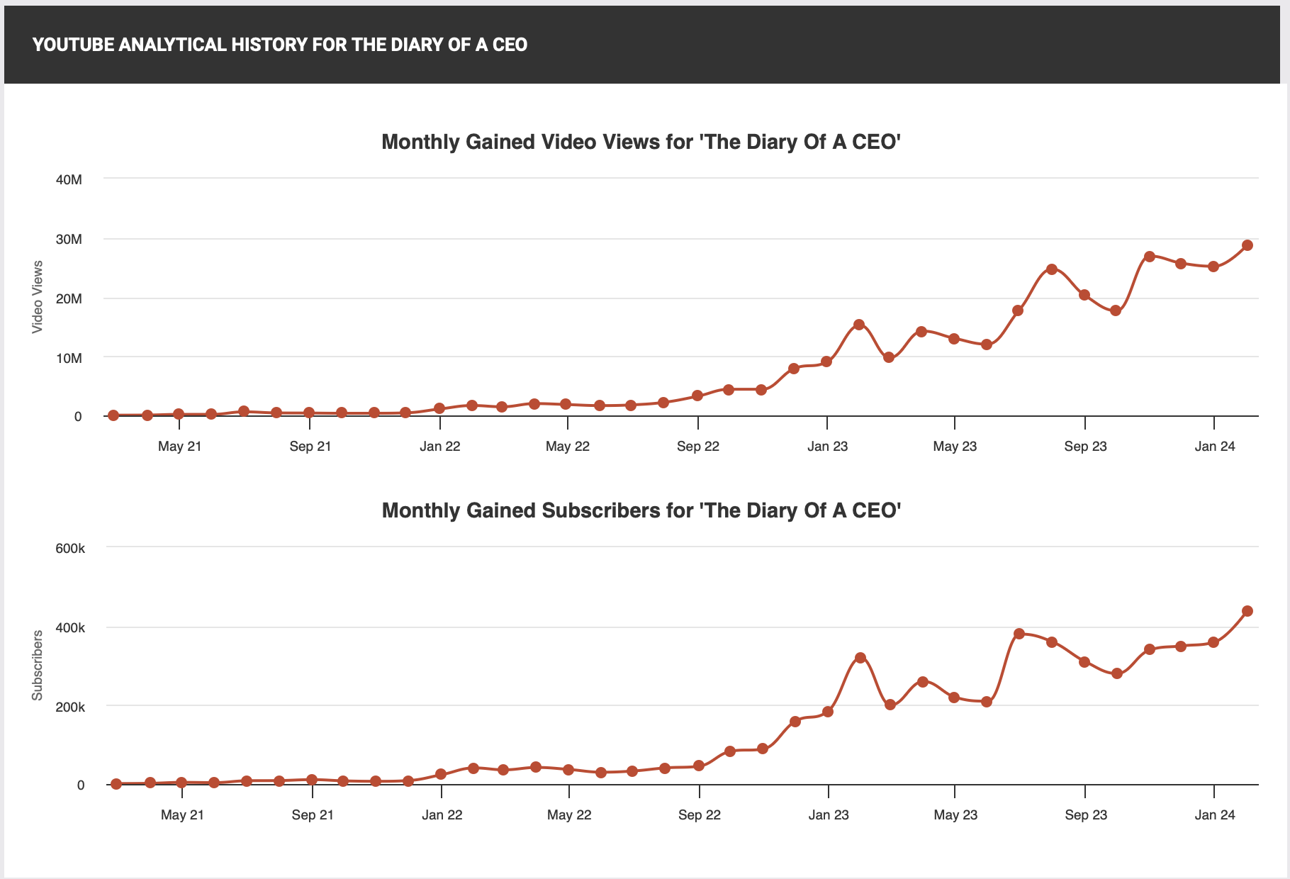

The channel is called The Diary Of A CEO and all they do is use a face and some simple text and thats it

BUT we need to go one level deeper, so to understand what's actually going on here im going to show you more channels blowing up using it and how to do it yourself

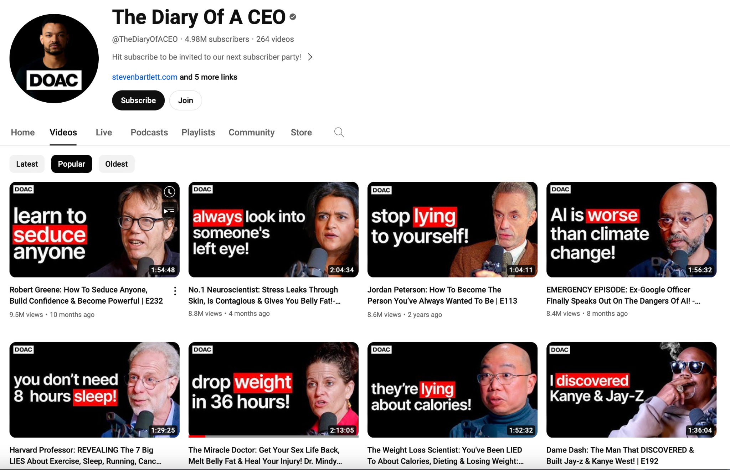

So This thumbnail in particular I want you to take note of👇🏼. 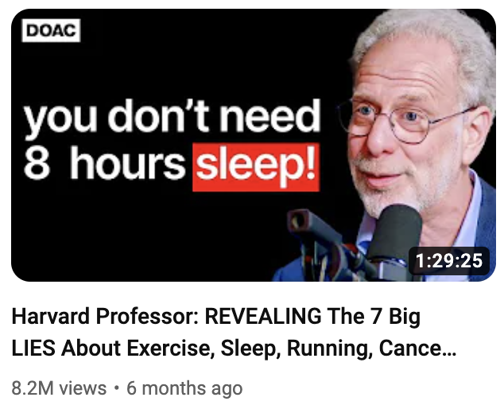

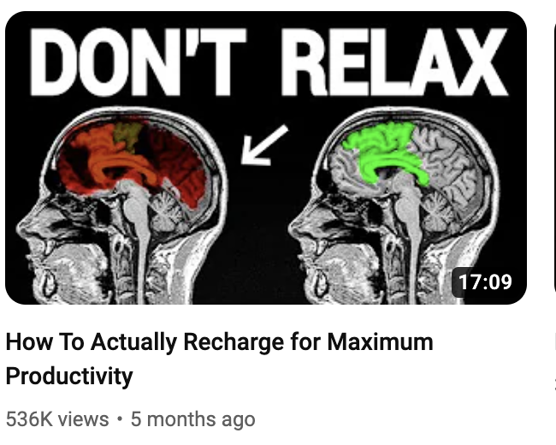

This image is again, very simple but it's using exact the same strategy as The Diary Of A Ceo as well as the one

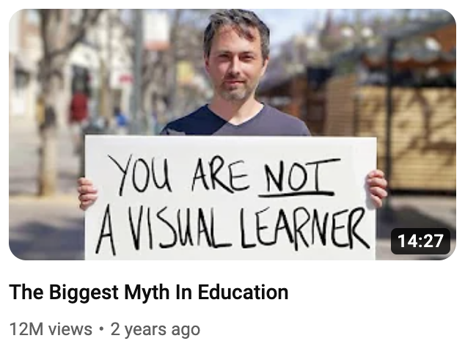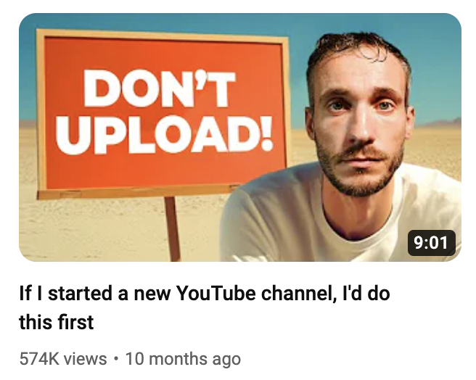
And one of videos from my old channel Film Booth

SO Why are these so powerful for generating views?
The reason these thumbnails have helped the videos explode comes down to a few things.
Firstly, they are very simple and are designed so that the text is the thing that stands out fast; if it didn't, what happens next wouldn't be as effective.
So its critical that when you try this, you don't over design them and make the text a secondary part of the image
The diary of the CEO thumbs do this so well because the highest point of contrast is black and white which basically means, the text probably couldn't stick out any more even if it tried
I mean look what happens when i use yellow and green and blue and red.
The next reason, and the most powerful, is due to this
When we see information that goes against what we believe, it makes us feel uncomfortable. This is called cognitive dissonance.
Cognitive dissonance is a big word to describe feeling uncomfortable when you have two different beliefs or when your actions don't match your beliefs.
SO for example we've all been told for ages that we need to have 8 hours sleep right….
And weve been told to relax and that were visual learners and of course to upload lots of videos
So you want to click to find out what the heck is going on here that challenges what we thought to be true
These thumbnails suggests that there is more to learn, that maybe we missed out something important and they're click magnets because it builds a curiosity in us which is key to getting clicks
But how do you make this thumbnail style for yourself so you can blow up your views and your business?
Step 1: Ask yourself, based on the topic i want to talk about, what do most people believe to be true that isn't?
If you're struggling for ideas, head over to Chat GPT and type, “I need some examples of things that could create cognitive dissonance in the music production niche.”
(You’d insert your own niche, of course.)
It’ll then fire out a list of examples, and do you know what... it's pretty good at it too!
Here are a few statements it came up with in relation to music production:
"Good marketing can make any song a hit, even if the production quality is poor."
"You don't need to know music theory to make hit songs."
"Expensive gear doesn't make your music sound better; knowing your tools does."

Step 2: Work out how to get this statement down to 4 words or fewer.
Although some of my examples don't do this, as a general rule of thumb, we want fewer words so the thumbnail is faster for people to read. DO NOT Turn your thumbnail in to a title.

Step 3: Design so the text sticks out first.
A few simple ways to do this are to:
- Make the text the highest point of contrast on the page which ive spoken about,
- Point arrows at the text.
- Keep the designs very simple so nothing competes with it.

Step 4: Is all about context and complimenting
Ryan’s team used a brain in the “don't relax” image as it tells the viewers straight away what the topic is related to
You could use an item, a person, or anything else that visually gives context to the topic. Or just keep it very simple like Diary of a ceo and let the words give that context
I dont recommend you do this. “DONT DO THIS” with no context to the topic because it could be about anything right!
If you’re in the image, make sure your expression matches the statement too; the days of over-the-top, mouth-wide-open photos are dead, so think about the emotion you want to convey and see how you get on.
There’s a few other things I think are really important here too
Firstly look at this, which one feels more credible to you?
Puling out stills from a video should only be something you do because you had no option, the smart move is just to batch shoot a tonne of photos of you making different expressions with a quality camera and quality lighting set up and then just use them on going
YOu’ll notice on a lot of channels they just use the same photo over and over again, this saves so much time and business tubers really dont have to reinvent the wheel for every vid
And then this next part is the genius part
If you want to grow your channel you have to learn about what appeals to your viewers and what doesn't
And one amazing way to do that is to make three versions of a thumbnail with different words on them.
Then pick the one you think works best then on launch wait a few hours and see how it performs, if it doesnt do well, you can switch it up to the next statement.
What can happen over the coming hours is you see the views spike and that means people are more interested in whatever the words were on the new image
When you learn this you can then reuse the same words in new titles or do a slight variation in future videos
So its a really simple way to discover what viewers care about without having to spend days designing multiple images,
There is one issue with this though. New and small channels, you guys dont really get enough impressions to learn from on release so you’ll have to be more patients and potentially wait days or weeks before you make a switch
its critical you always have at least 3 versions of an image though,
i mean look at this video, it was a 9/10 in the first few hours, i switched to this thumbnail and it didnt work, then to this and hey presto.
Having just one thumbnail is a death sentence for your content
But how is this going to make you more money ?
Well for those of you who have an offer already, more views should equal more email sign ups and more sales so long as you’ve got your marketing sorted thats why
But for those of you who don't, every video you make is training you to understand what your viewers are interested in, when you learn about what copy attracts them, you can use this same strategy all over the place
So for example you could use it as a hook in a post to drive attention towards your email list or when you do start making a landing page for an offer, use it as a headline hook to drive the viewers further down the page so they want to read more!
Theres small YouTubers all over the place using hooks of this nature to grow their channels and make big money and if you’d like to learn how else they generate 6 and 7 figures incomes from sometimes tiny views watch this video next to discover the secret to making money on YouTube

